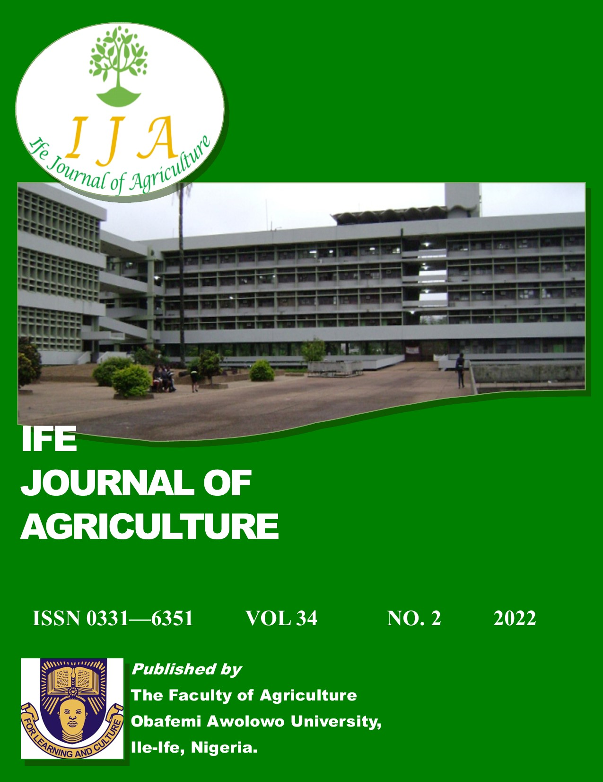
VOL. 36 NO. 1 2024

Ife Journal of Agriculture
Editorial Board
Prof. (Mrs.) B. O. Ogunba Editor–in–Chief
Dr. J. A. Odedire Assistant Editor–in–Chief
Dr. K. O. Bakare
Dr. J. O. Ayinde
Dr. V. A. Tanimonure
Dr. R. O. Akinwale
Dr. F. O. Tijani
Dr. T. O. Ojo
Ife Journal of Agriculture is a bi-annual publication devoted to publishing original scientific papers in any field of agriculture and related disciplines. It will also publish review articles and theoretical papers of concern to agricultural development in the tropical world. Book reviews, notes and short scientific communications will be entertained.
Guide for Authors
Click on this link
Submission of Manuscripts
Email: ifejournalagric@gmail.com
TABLE OF CONTENTS
TITLE | PAGE NO.
EFFECT OF ASPERGILLUS NIGER TREATED FIBRE FEEDSTUFFS ON GROWTH PERFORMANCE AND CARCASS CHOLESTEROL OF GROWING PIGS  AFENI, M. O¹., ADEYEMI, M. A²., OGUNDEJI, S. T¹. AND AKINFALA, E. O^{1*} | 01 – 09
EFFECTS OF FISH CAGE–CULTURE ON ZOOPLANKTON ABUNDANCE IN THE TROPICAL RESERVOIR OF ITAPAJI, SOUTH-WEST, NIGERIA  AKINSOROTAN A. M. ¹*, EDEWHO E. U. ¹, IYIOLA A. O. ², ADESOYE A. F.¹; OMOTOSHO P. F.¹ AND ADEJAYI O. O.¹ | 10 – 22
ACCEPTABILITY, PERCEIVED BENEFITS AND CONSTRAINTS OF HOME-MADE PLANTAIN WINE (AGADAGIDI)  ALABI, D. L*. AND ODUSANYA, O. G. | 22 – 30
CLIMATE CHANGE INDICATION ACROSS FOUR STATES IN NIGERIA: HEAT LOAD INDEX AND MULTIVARIATE ANALYSIS  TOWOLAWI, A.T.^{1*}, OGUNTOKE, O.², BADA, B.S.², ADEJUWON, J.O.³, ABDULSALAMI, B.A.⁴, AND ADEGBORE, A.K.⁵ | 31 – 45
GENETIC DIVERSITY AMONG SELECTED KERSTING'S GROUNDNUT ACCESSIONS BASED ON SSR, SCoT AND RAPD MARKERS  OLUFEMI S. O¹³., ODESOLA K. A^{1,2}., OLAWUYI O. J¹ | 46 – 62
EFFECT OF FERTILIZER ON INCIDENCE AND SEVERITY OF CERCOSPORA LEAF SPOT AND YIELD-RELATED TRAITS OF KENAF (HIBISCUS CANNABINUS L.)  *ODUWAYE O. F. AND OLANIPEKUN S. O. | 63 – 73
STATE OF SOIL RESEARCH IN SOUTHWESTERN NIGERIA: THE ACHIEVEMENTS, CHALLENGES AND WAY FORWARD  J. O. OJETADE | 74 – 88

